***Artificial Intelligence***

***CSL 411***

***Lab Journal 10***



**Student Name:Rida sajjad**

**Enrolment No.01-134152-063**

**Class and Section:BsCs-7B**

**Department of Computer Science**

**BAHRIA UNIVERSITY, ISLAMABAD**

**Lab # 10: Unification, Recursion, First Order Logic, Expert System.**

**Objectives:**

To implement the concept of recursion in prolog.

**Tools Used:**

**Swi- Prolog Editor.**

**Submission Date:**

**Evaluation: Signatures of Lab Engineer:**

**Task #1:**

Write a program in Prolog to find a route on the London Tube if the given stations are on the following three lines: (Lines will be assigned to you by the Lab Engineer).

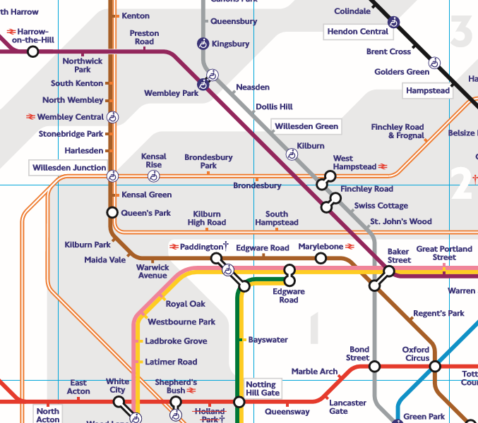

**Procedure/Program:**

% Author:

% Date: 27-Nov-18

adjacent(np,sk,bakerloo).

adjacent(sk,nw,bakerloo).

adjacent(nw,wc,bakerloo).

adjacent(wc,sp,bakerloo).

adjacent(sp,h,bakerloo).

adjacent(h,wj,bakerloo).

adjacent(wj,kr,lo).

adjacent(kr,bp,lo).

adjacent(bp,bb,lo).

exist(X):-adjacent(X,_,_);adjacent(_,X,_).

path(X,Y):- adjacent(X,Y,_).

path(X,Y):- adjacent(X,Z,_),

path(Z,Y).

direct_connect(X,Y,Line,S,[Y|S]):- adjacent(X,Y,Line).

direct_connect(X,Y,Line,S,F):- exist(X),

exist(Y),

adjacent(X,Z,Line),

direct_connect(Z,Y,Line,[Z|S],F).

route(X,Y,F):-exist(X),exist(Y),

direct_connect(Z,Y,_,[X],F)

**Result/Output:**

